Weekly lesson plan
Subject – Social Studies ( history )
Class- VII
Date- 1801.2021- 24.01.2021- 30-01-2021
Topic- religious belief period-3
Sub topics are-
Bhakti- meaning and o r I g I n
Main features of Bhakti moment
Bhakti song
Bhakti movement in North India
Sufism
Case study of Kabir, Guru Nanak
Instruction Aids-
https://youtu.be/TgmRJkKc9wA
https://youtu.be/APysudz7V9s
https://youtu.be/ZLRz8Fe5OsY
NCERT BOOK: https://ncert.nic.in/textbook.php
LEARNING OUTCOMES;
- Meaning of bhakti
- Able to understand the main feature of Bhakti movement.
- Take knowledge about Bharati Sants.
- Will know about Nath pantis., Siddhacharas and Yogis.
- Students will know Bhakti movement in India.
Lesson development
Introduction-
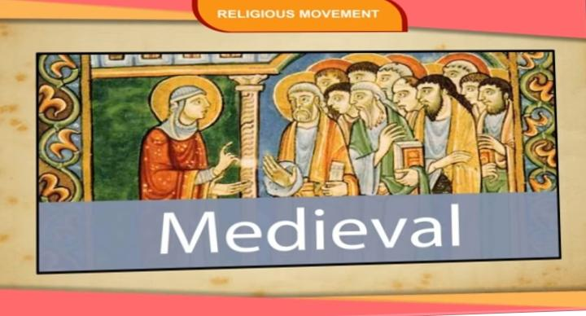
In mediaeval India people worshipped God in generally two ways. Either they would recite and perform and perform various ritual under the guidance of priests, or they participated in singing and chanting in large group in praise of deities.

Bhakti: meaning and origins –
- The method of worshipping aur offering prayers to the God through simple act of devotion is called the bhakti tradition of worship. Bhakti essentially means selfless love for God. The idea was first expressed in Bhagwat Geeta but it became widespread in the early century of common era.
The main feature of Bhakti movement

The main feature of bhakti moment were as under:-
Devotion To one God- The preachers of Bharti moment advocated their devotion to one God.
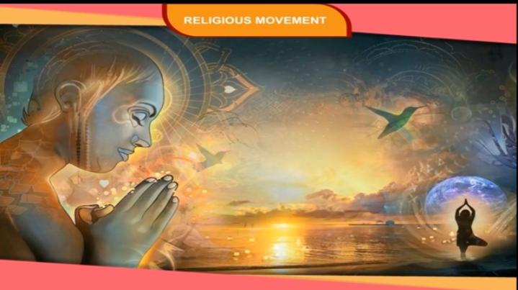
Loving devotion –
This moment impressed on devotion individual worship of God’s aur goddess rather than performing elaborate ritual and sacrifices.
Beginning of temples-
Since the deities were special, their images were placed within special homes. These homes come to be known as Temples
Emphasis on moral values-.
The preachers of this moment stressed on the virtues of kindness, purity is of the heart and mind.
Bhakti Sants—
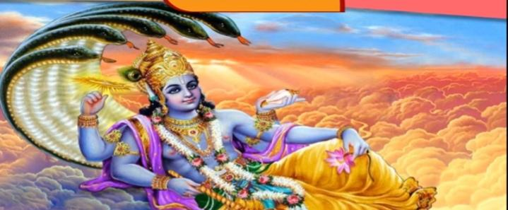
Alwars and Nahin Nayanars
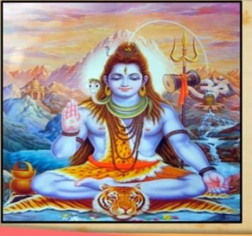
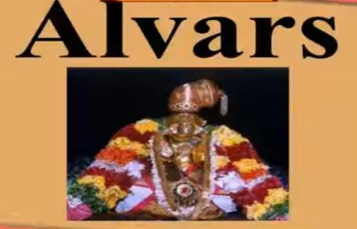
The Bhakti movement began in South India in the 7th Century by the Alwars Who worshipped Vishnu and Narayans Who worshipped Shiva. The Bhakti movement rejected caste system. They believed that the God can be read only true true love devotion and complete self surrenders. Bhakti Sant live the Alwar Naina give no importance to expensive and complicated ritual and ceremonies. People for many caste including they are untouchable could join the movement.
Shankaracharya- Shankaracharya was one of the well known and influential philosopher of South India, who was born on Kerala. He gave the idea of advita, aur Idea Oneness of the individual soul and Supreme God.
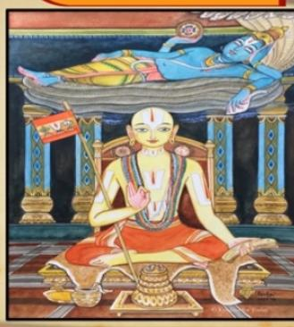
Ramanuja- ramanuja was born in Tamilnadu in the 11th century. He was deeply influenced by the Alwars. He praised that an extreme devotion to Vishnu would help the devotees to attain salvation and bliss to Union with him. He Propounded the idea of Vishishtadivita.
Saints of Maharashtra:- between the 13 and 17 centuries many saints of Maharashtra popularized the Vitthal worship.They worshipped Vitthal of Pandharpur. the most important of the Vishwanva saints were janeshwar, Namdev, Eknath and Tukaram. They also included women Sant like Sabko bhai and the family of chokhamela who belonging to the untouchable Mahar caste. The sons were called varakaris.
Bhakti movement in North India
Surdas
Surdas was a devotees of Lord Krishna. He was born blind. He composed many Dohas or couplets which became very popular.His poem are completed in the sursagar.
Tulsidas
Tulsidas was ardent devoted of Lord Rama. He composed Ramcharitmanas in avadhi. The language of eastern Uttar Pradesh. Through his work, he expressed his complete devotion towards Lord Rama.
Chaitanya Mahaprabhu ( C. 14885-1535)
Chaitanya was the most prominent Vishwanva Saint of Bengal. He popularised Krishna bhakti in many part of Eastern India. He disregarded all distinctions of caste, greed and 6 to give a popular base of Krishna bhakti. His follower belonging to all the cast communities. One of his most favourite disciples was Haridas who was a Muslim. He popularised the practice of Sankirtan aur group devotional singing accompanied by ecstatic dancing.
Ravidas
He was a great Saint who belonging to Aakash considered untouchable. He was an ardent of Lord Krishna.
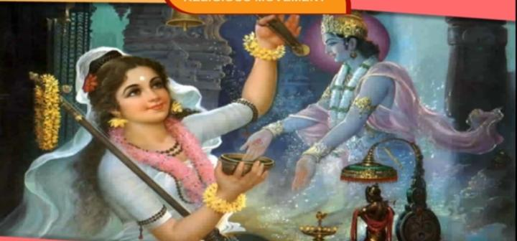
Mirabai
Among the devotee of Lord Krishna cult of bhakti. Mirabai deserve a prominent please. She was born in about 14 98. She was married to Rana sang’rs eldest son Bhojraj.
Sufism
During the Sultana period, number of Muslims come to India and Saturday and down in different part of subcontinent. There frame and popularity spread as Delhi saltanat and the Mughal Empire spread over the subcontinent.
The Muslims saints who come to India priest a new type of devotion of God. I did not believe in ritual and sought to unite with God through selfless love alone. It become to known as Sufism. Sufism first developed in West and Central Asia. Some of early Sufi Saints were Rabeya, mansur bin, hallaj and alu ghazzali.
Of all the 12 orders of Sufi Saints, the chishti and suhrawardi silsilas become important in subcontinent. The chishti order had a long line of famous saints like khwaja muin-ud-Din Chisthi of Ajmer,,, Qutab -ud-Ddin Bakhtiyar kaki of delhi, Farriduddin Sikri, and Bandanawaz Ghesudaraz of Gulllbargra.etc.
Case study
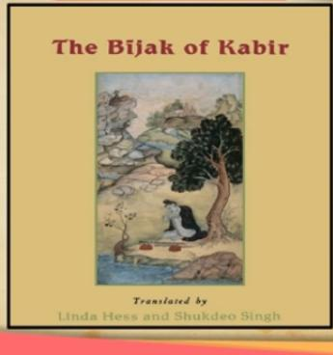
Kabir- Kabir(C. 1440 -1580) why the earliest and undoubtedly the most powerful figure of the monotheistic moment that begin of 15 century. He belong to a family waivers( julaha) who were indigenous converts to Islam. He is pant greater part of life in Banaras
Is varsh very included in Sikh scripture, the Adi Granth, in panchvani and in bajaj in the large number of them those of other Monotheists. Kabir believed in Oneness of God, irrespective of the names by which human beings addressed him. The teaching of Kabir ah-in the form of short poems and couplets calles doohas. They passed from one generation to the next in oral tradition. After his death the word of Kabir verb put down in writing known as Kabir Vanis. Let on Kabir granthavali and bijak were composed which contained philosophy of Kabir, after his death the followers of Kabir, which include both Hindus and Muslims, come to be known as kabirpanthis.
Guru Nanak
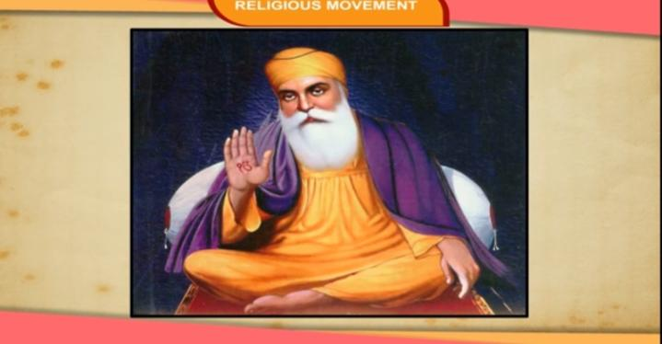
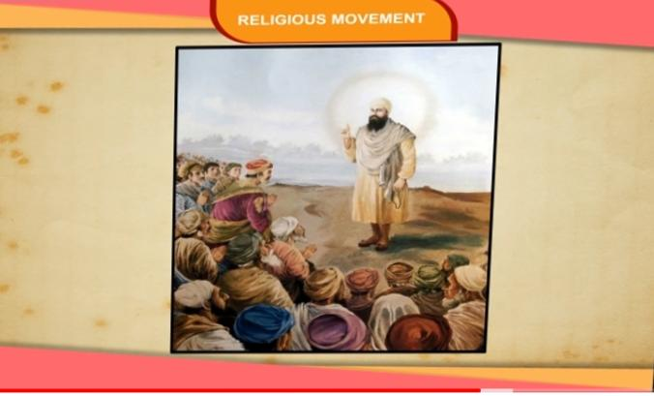
Guru Nanak(C. 1469- 1539) preached is idea much in the same way as Kabir and others monotheists, but due to various developmentss later after his teachings led to the emergence of Mass religion, Sikhism. The basic similarities of his teachings with those of Kabir and other saints made Him and an integral part of the monotheistic moment.
He belonging to a caste of traders called Khatri was born in a village in Punjab now known as Nana Sahib. In his later life he travelled widely of preach his ideas. There he attract a large number of disciplies. The hymns composed by him were incorporated in the Adi Granth by the fifth Sikh Guru Arjan in 1604. To Heels complication were added the writing in other figures like Shaikh farid, Sant Kabir, Bhagat Namdev, Guru Teg Bahadur. EN 1706 his complication was authenticated by his son and successor,Guru Govind Singh.It is known as Guru Granth Sahib, the holy scripture of Sikhs. Guru Nanak impressed the, importance of the worship of one God. God for nanak was non-incarnate, the formless( Nirankar) internal( Akal)and ineffable ( alakh).

Summary –
- During the mediaeval period, a new tradition of worship emerged. Which was called Bhakti tradition.
- The bhakti tradition rejected inequality and rituals.
- All the bhakti saints preached selfless devotion of God.
- Bhakti Saint of mediaeval period hailed from all over India, belonging to different caste and communities.
- There was a great variety among the bhakti saints. Some of them worshipped while other worship Vishnu. There was still other who were the water of God without any form or name. But all of them impressed the value of love, peace and fraternity among people.
- Like the bhakti saints, sufi saints laid stress on stress on selfless devotion of God.
- Sufis in India were divided into 12 Silsila song orders. Of these chishti and suhrawardi silsila wre most prominent.
- Guru Nanak and Kabir what two of the greatest Saint of mediaeval period.
- Guru Nanak LED the foundation of Sikhism.
- They rejected orthodox religious practice spoke of God without form of name.
Activity-
Investigate the customs tradition and other practices followed in your locality by the different communities and make a list.
https://youtu.be/Q8EuvTlrFsk
Evaluation –
Answer this question –
- What is Bhakti?
- What did Shankaracharya preach?
- Define Silsilah?
Fill in the blanks
- _______________[ essentially means selfless love for God.
- Bhakti Saints sang_________________ song in praise of the deity..
- Chaitanya was the most prominent Vishnu Saint of ___________.
- _______________ belonging to a family weavers.
- Guru Granth Sahib is the holy scripture of the_______________
Write true or false:-
- Bhakti Saints taught and wrote in Vedic Sanskrit.
- The alvas and nayanarrs attracted many female devotees.
- Mirabai lyrics in the Brijj bhasha are the finest specimens of Hindi Diwas poetry.
- Kabir supported Idol worship in a big way.
Give the answer of multiple choice question.
Question 1. Which devotional path evolved since the 8th century?
(a) Bhakti
(b) Sufism
(c) None of these
(d) Both of these
Question 2. Which was NOT the supreme deity of Hindu worshipped during Bhakti movement?
(a) Shiva
(b) Vishnu
(c) Ganesha
(d) Durga
Question 3. Religious biographies are called
(a) autobiography
(b) geography
(c) photography
(d) hagiography
Question 4. Ramanuja was born in which state of India?
(a) Kerala
(b) Tamil Nadu
(c) Andhra Pradesh
(d) None of these
Question 5. Allama Prabhu was the companion of:
(a) Ramanuja
(b) Basavanna
(c) Shankara
(d) Kabir
Question 6. Vitthala is a form of
(a) Shiva
(b) Vishnu
(c) Krishna
(d) Ganesha
Question 7. Who rewrote the Gita in Marathi?
(a) Saint Janeshwara
(b) Chaitanya
(c) Basavanna
(d) Virashaiva
Question 8. Nathpanthis, Siddas and Togis made devotional religion popular in:
(a) North
(b) South
(c) East
(d) West
Question 9. Sufis were ………. mystics.
(a) Hindu
(b) Boddh
(c) Muslim
(d) Christian
Question 10. The Sufi master held their assemblies in their
(a) temple
(b) courtyards
(c) Khanqahs
(d) none of these

